**Bash Scripting Day-2**

1. ***Create a bash script to check if a directory is available or not.***

* Create a bash file with extention bash/.sh
* Enter the Bash Script as the given syntax

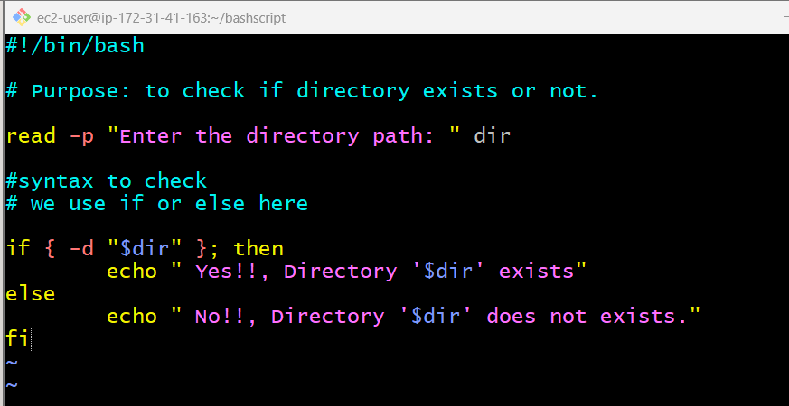

* Change the permission to 755 to the file

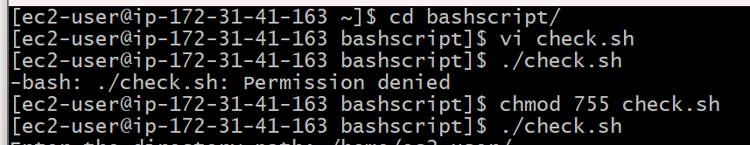

* read -p prompts the user to enter a directory path.
* [ -d "$dir" ] checks if the path is a valid directory.

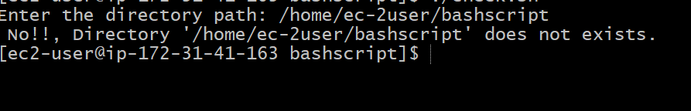

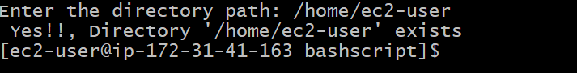

1. **Create a bash script to create multiple files.**

* Create a bash file with extention bash/.sh
* Enter the Bash Script as the given syntax

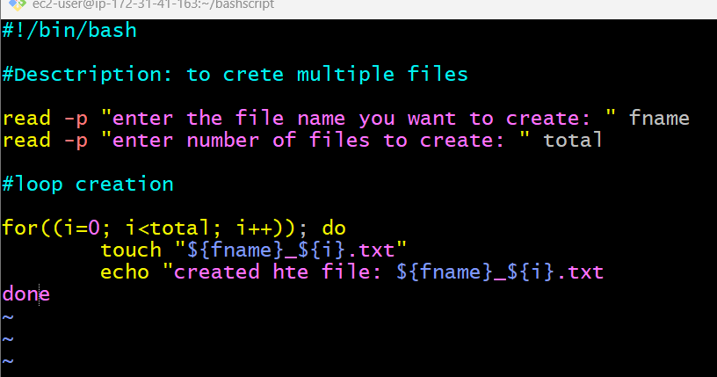

* Change the permission to 755 to the file

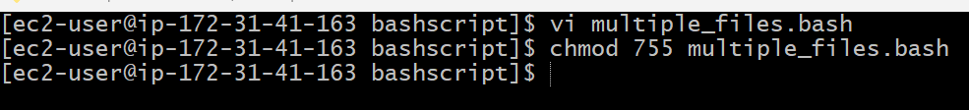

* read collects user input for the fname and how many files to create.
* touch creates each file with a numbered suffix techie.txt, techie2.txt, etc.
* The loop runs from 0 to the number you specify.

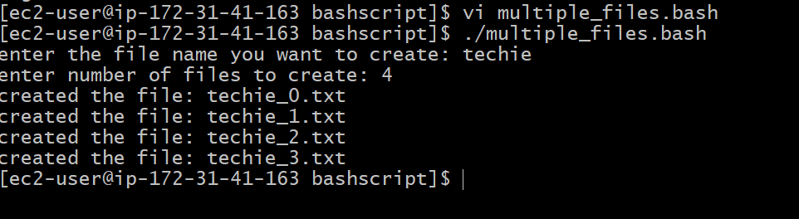

1. **Create a bash script to take a backup of a directory.**

* Create a bash file with extention bash/.sh
* Enter the Bash Script as the given syntax

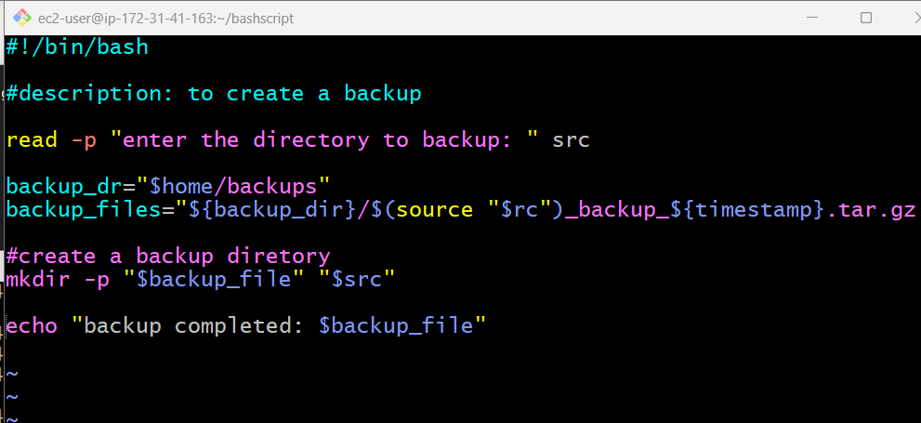

* Change the permission to 755 to the file





1. **Create a bash script to install Nginx on an EC2 server.**

* Create a bash file with extention bash/.sh
* Enter the Bash Script as the given syntax

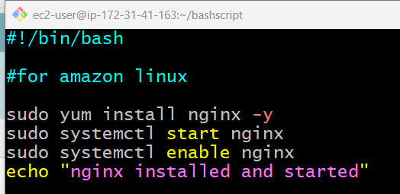

* Change the permission to 755 to the file

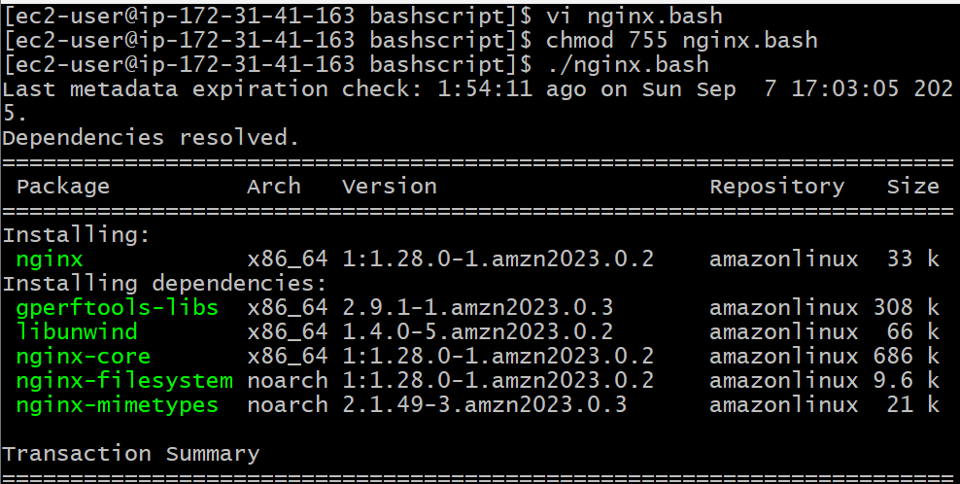

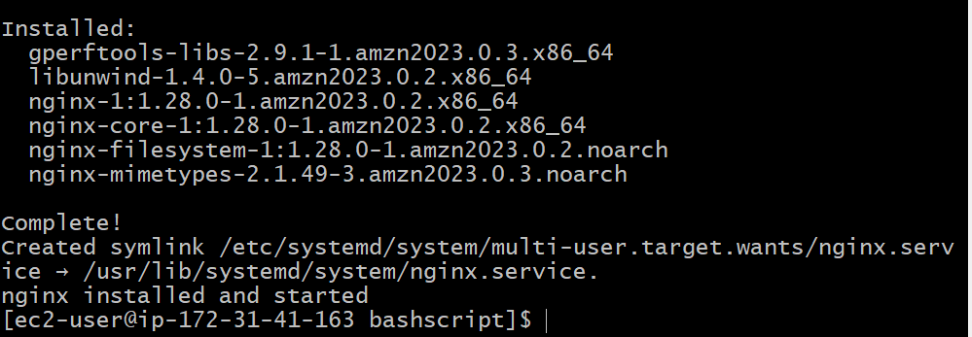

1. **Create a bash script to install Apache Tomcat on an EC2 server.**

* Create a bash file with extention bash/.sh
* Enter the Bash Script as the given syntax

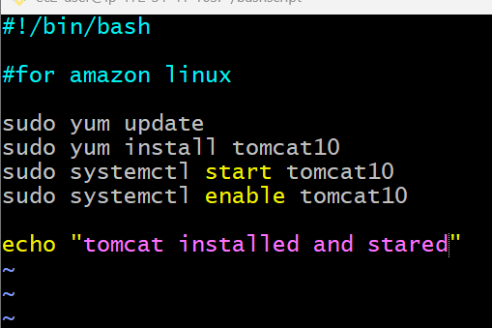

* Change the permission to 755 to the file



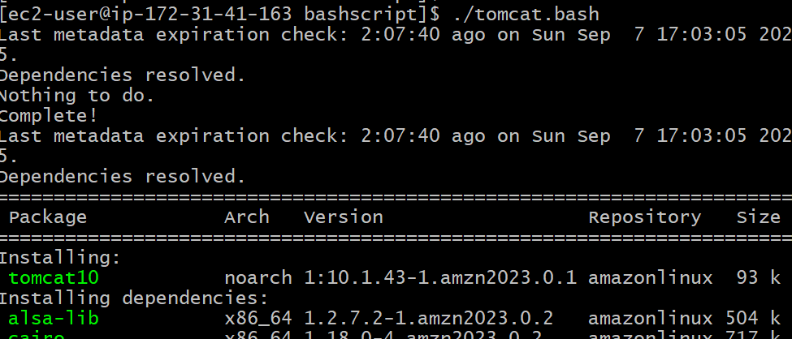

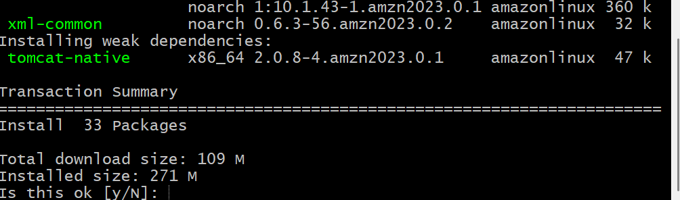

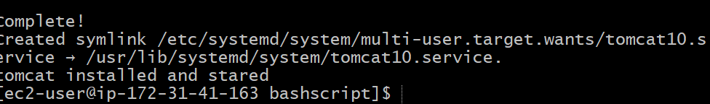

1. **Create a bash script to check if the Nginx service is running, if not running then script should start the service.**

* Create a bash file with extention bash/.sh
* Enter the Bash Script as the given syntax

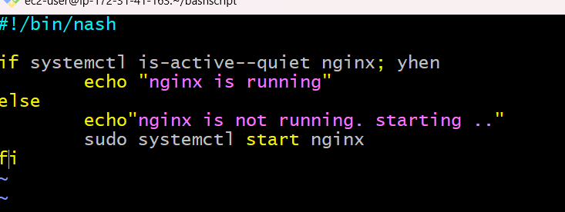

* Change the permission to 755 to the file



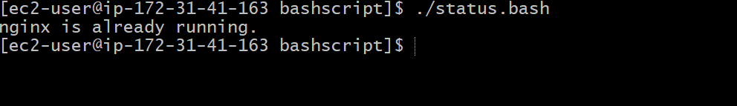

1. **Create a bash script for a calculator.**

* Create a bash file with extention bash/.sh
* Enter the Bash Script as the given syntax

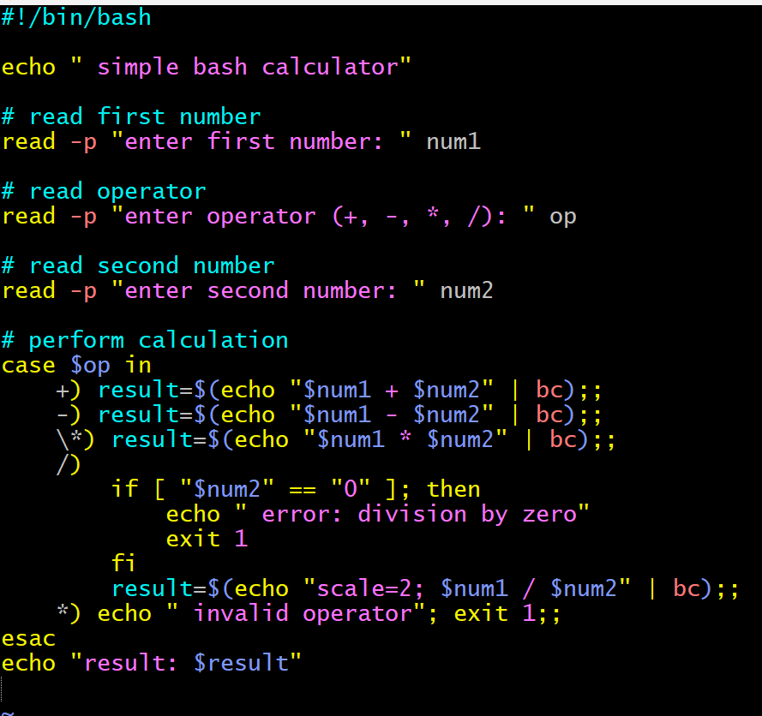

* Change the permission to 755 to the file

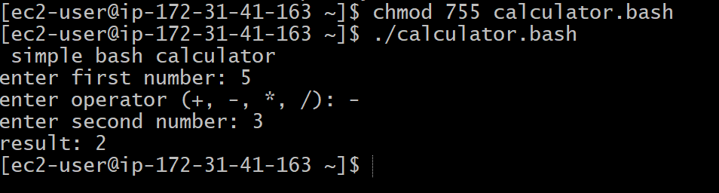

1. **Create a bash script to check if a directory exists, if not then create a directory.**

* Create a bash file with extention bash/.sh
* Enter the Bash Script as the given syntax

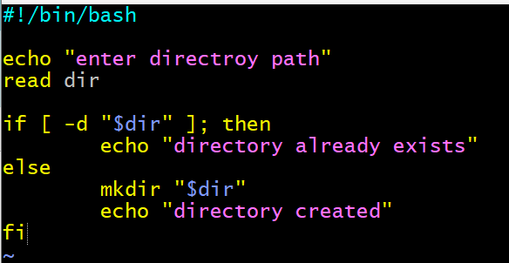

* Change the permission to 755 to the file

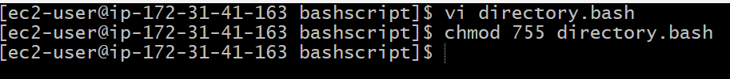

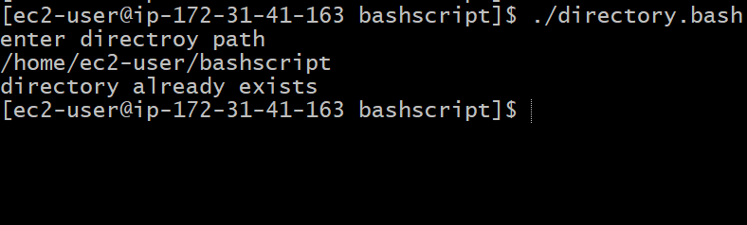

1. **Create a bash script to delete the last 3 lines of a file.**

* Create a bash file with extention bash/.sh
* Enter the Bash Script as the given syntax

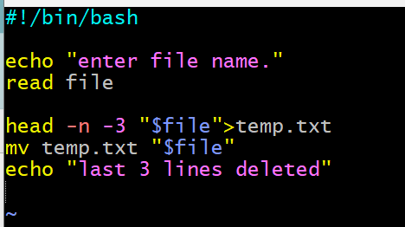

* Change the permission to 755 to the file

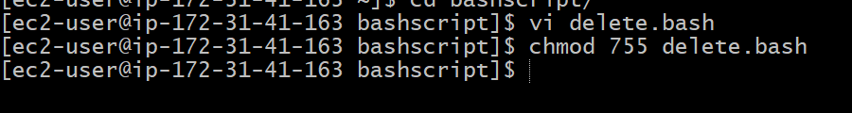

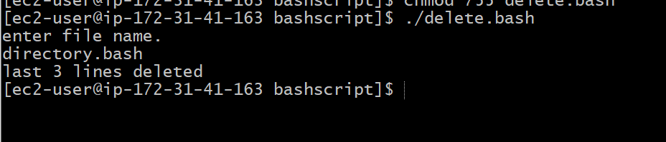

1. **Bash script to monitor cpu and if it is more than 80% then send email notification.**

* Create a bash file with extention bash/.sh
* Enter the Bash Script as the given syntax

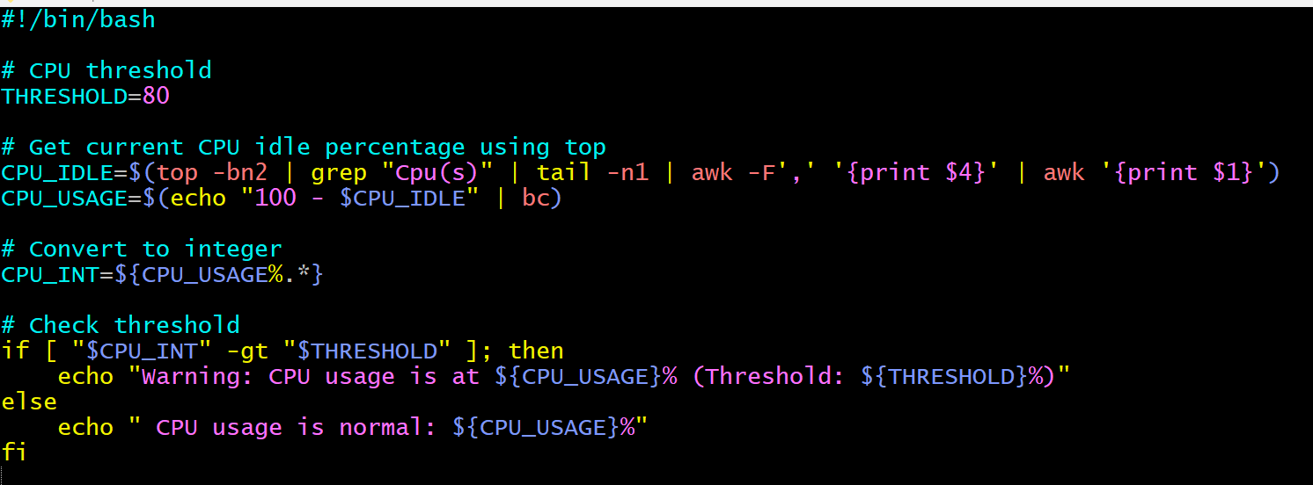

* Change the permission to 755 to the file
* To get the email, mail must be installed and set for use.
* Check the CPU usage with the htop, top commands. Once the usage exceeds 80%, an automated email is sent to the email entered in the script.

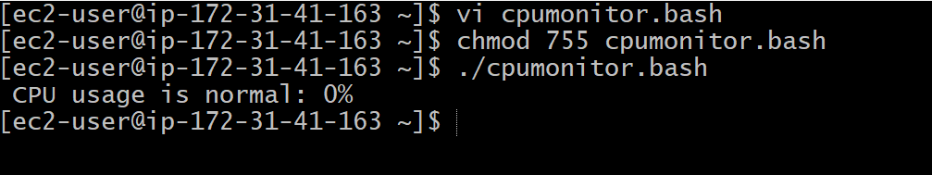

1. **Bash script to monitor disk space and if it is more than 80% then send email notification.**

* Create a bash file with extention bash/.sh
* Enter the Bash Script as the given syntax

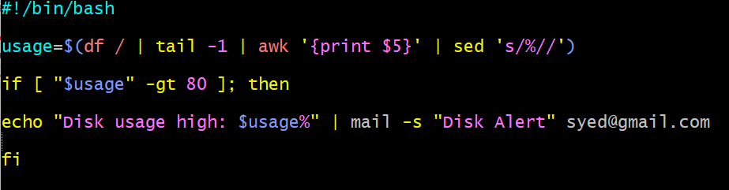

* Change the permission to 755 to the file
* To get the email, mail must be installed and set for use.
* Check the disk usage with the “df -h” command. Once the usage exceeds 80%, an automated email is sent to the email entered in the script.



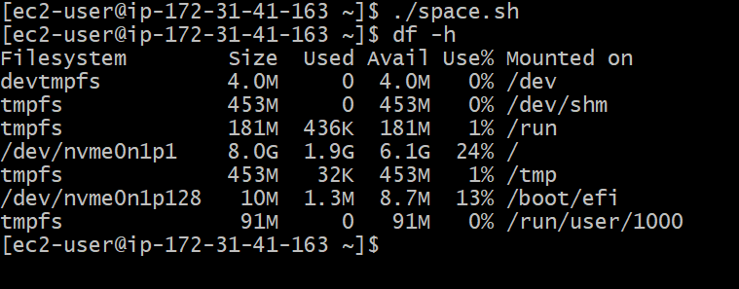

1. **Bash script to monitor memory and if it is more than 80% then send email notification.**

* Create a bash file with extention bash/.sh
* Enter the Bash Script as the given syntax

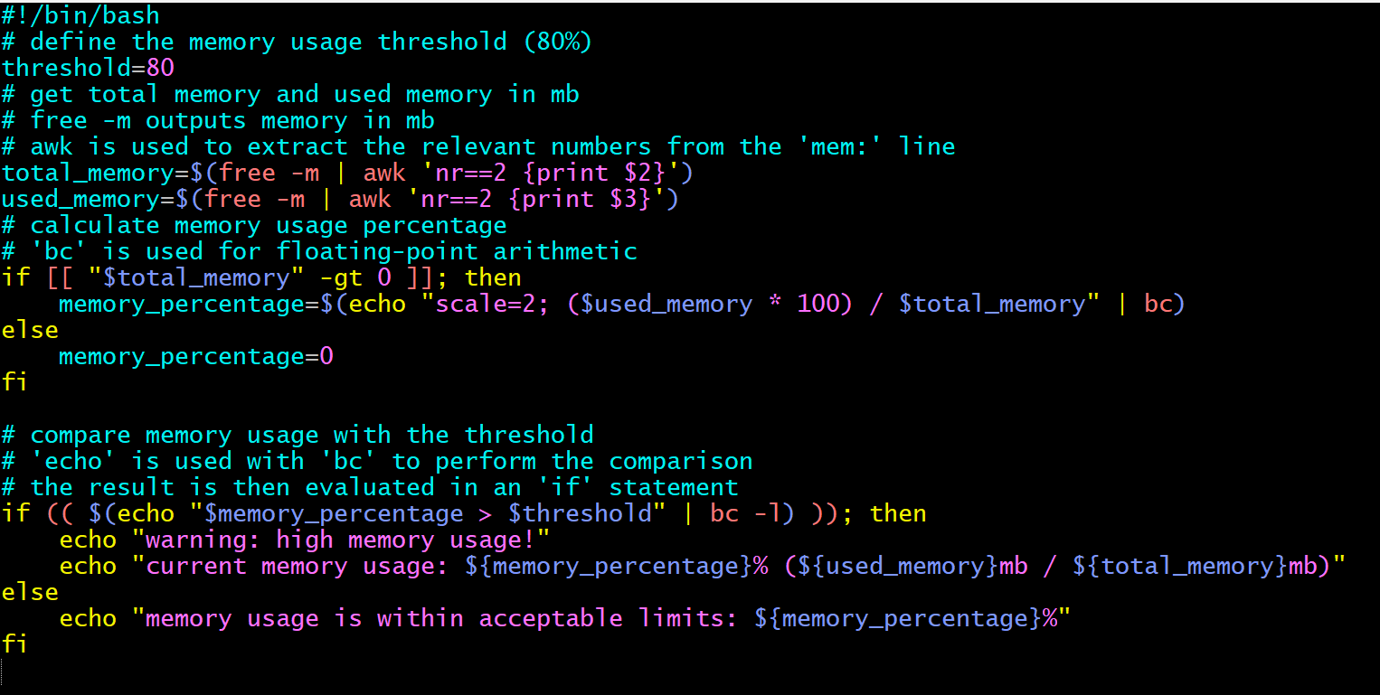

* Change the permission to 755 to the file

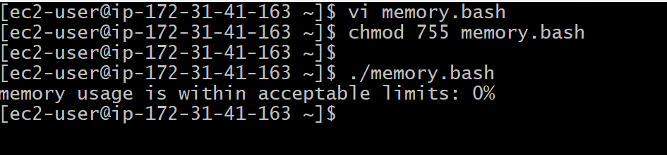

* To get the email, mail must be installed and set for use.
* Check the memory usage with the “free -m” command. Once the usage exceeds 80%, an automated email is sent to the email entered in the script.